Soldotna/Sterling Transmission line AWC
AWC Code 244-30-10010-2031

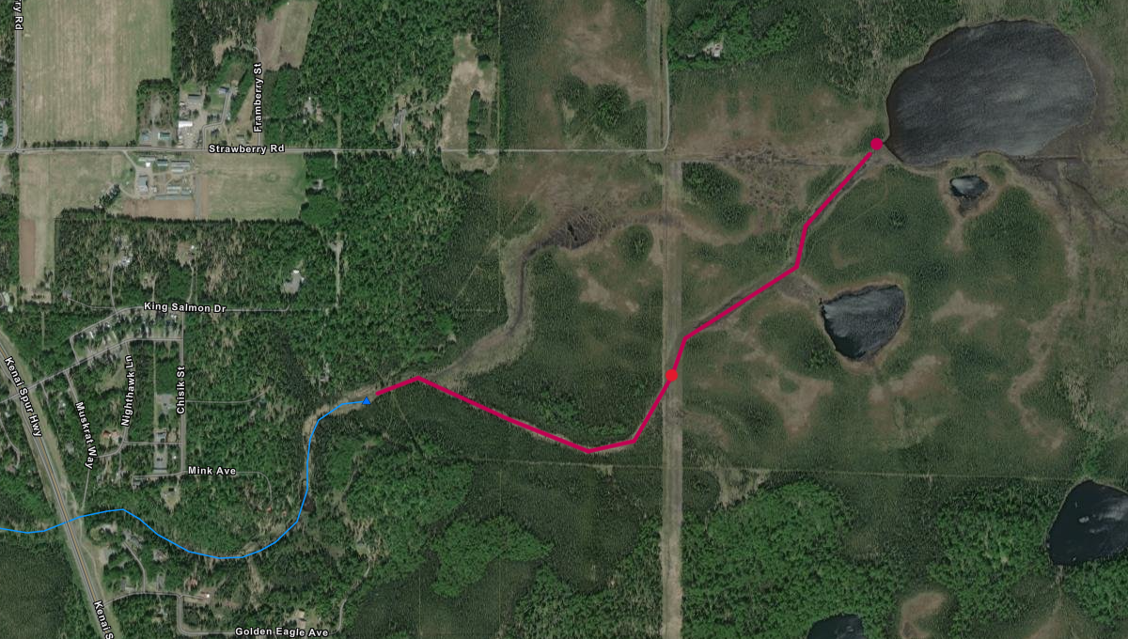
AWC Code
244-30-10010-2031
Upper extent of DV
60.5404 N, -151.0576 W

Upper extent of Coho
60.5457 N, -151.0481 W

